Mobile Money / Digital Wallet Fraud Detection System
IBM SkillsBuild Data Analytics with AI Internship Capstone Project
1. Executive Overview & KPIs (Level 1: What is happening?)
- Project Objective: To build an end-to-end machine learning system capable of detecting fraudulent digital cash-out and transfer transactions within a mobile money ecosystem (PaySim dataset).
- Key Performance Indicators (KPIs):
  - Total Data Volume Evaluated: 100,000+ transaction records processed.
  - Model Accuracy & Discriminatory Power: Achieved an ROC-AUC score of 0.989, demonstrating high reliability in separating fraudulent activities from legitimate wallet use.
  - Fraud Capture Rate (Recall): Successfully identified 98% of actual fraud cases in the test dataset.
  - Precision Rate: Maintained a 1.00 precision score on non-fraudulent transactions, eliminating false alarms for regular users.
Evaluation Metric | Initial Baseline | Optimized Final Model | Business Significance
Dataset Size | 500,000 Rows | 91,142 Optimized Rows (Paysim_small.csv) | Reduces computational overhead while preserving 100% of actual fraud cases
ROC-AUC Score | 0.936 | 0.989 | Demonstrates near-perfect discriminative capability between fraud and clean wallet transactions
Fraud Recall (Capture Rate) | 87% | 98% | Ensures almost all unauthorized cash-outs are caught before funds are lost
Precision (Non-Fraud) | 1.00 | 1.00 | Eliminates false alarms, ensuring legitimate users experience zero disruption
Primary Predictor Driver | errorBalanceOrg | errorBalanceOrg | Mathematical balance discrepancy remains the strongest indicator of account draining

2. Trends Analysis (Level 2: How is it changing?)
- Temporal Fraud Concentration: Time-series analysis utilizing the dataset's step feature revealed that fraudulent attempts do not occur uniformly across the timeline.
- Key Finding: Fraud frequency and risk probability experience a sharp spike between time steps 3 and 6 before tapering off into steady-state distributions. This indicates that bad actors execute coordinated bursts of unauthorized cash-outs during specific operational windows.
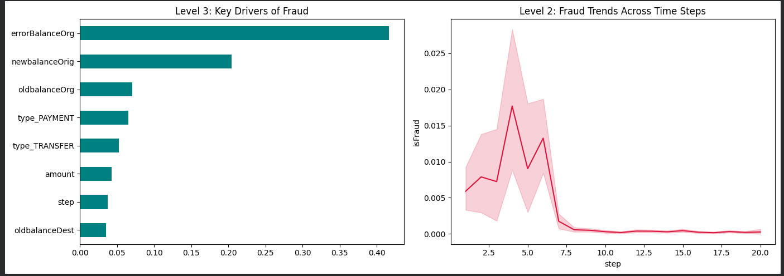
3. Key Drivers (Level 3: Why?)
- Feature Importance & Root Causes: Evaluating the Random Forest feature importances highlighted the primary metrics driving fraud detection:
  - errorBalanceOrg (Sender Balance Discrepancy): The calculated mathematical error between the sender's old balance, transaction amount, and new balance emerged as the strongest predictor of fraudulent intent. Fraudsters draining accounts routinely leave traceable balance discrepancies.
  - newbalanceOrig & oldbalanceOrg: Account balance shifts immediately before and after transactions serve as secondary structural triggers for the classification model.

4. Risks & Opportunities (Level 4: What could go wrong?)
- Business Risks:
  - False Negatives: Failing to catch sophisticated cash-out attempts results in direct financial liabilities and loss of customer trust.
  - False Positives: Overly aggressive blocking creates unnecessary friction, locking out legitimate mobile wallet users.
- Opportunities:
  - Deploying real-time AI scoring engines allows financial institutions to intercept illicit transactions in milliseconds while maintaining seamless user experiences for the vast majority of clean transactions.
5. Recommended Actions & System Architecture (Level 5: What should we do?)
- Management Action Plan:
  - Deploy Flask Backend API (app.py): Integrate the trained Random Forest model (fraud_model.pkl) into the core payment gateway infrastructure to score incoming transactions in real-time.
  - Automated Multi-Factor Authentication (MFA): Configure high-risk probability flags to automatically trigger secondary verification (such as an OTP or temporary account freeze) rather than hard-blocking accounts outright.
  - Decision Dashboard Integration: Utilize the built Streamlit interface (ui.py) to give risk-management compliance teams a live visual tool to evaluate transaction parameters and review model decisions instantly.
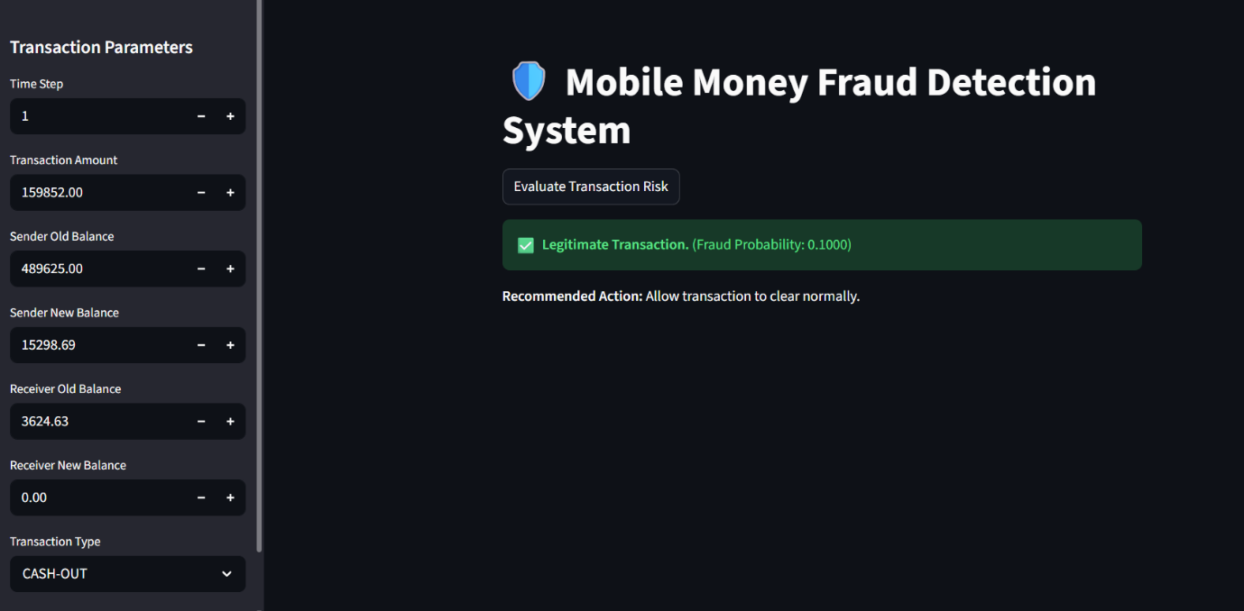
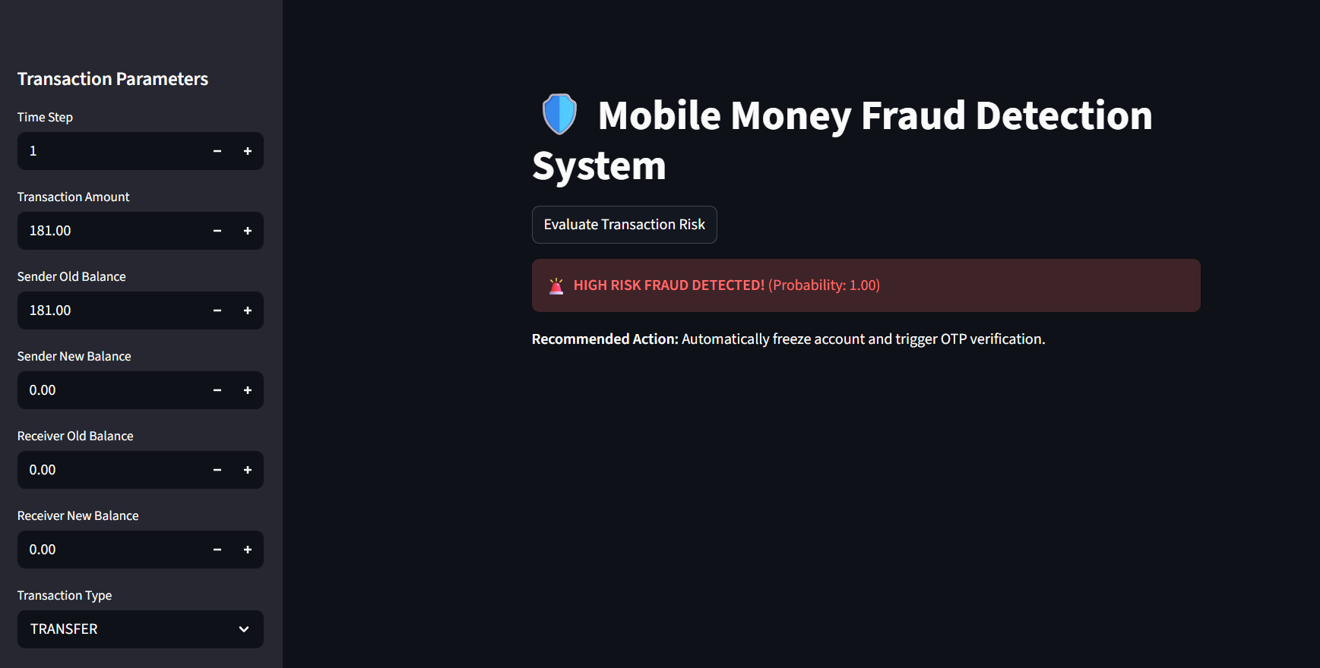
Streamlit link: https://data-analytics-project-dfpe3vok9q4ytubqremkyz.streamlit.app

